What is Data Structure?
The data structure name indicates itself that organizing the data in memory
Importance: Why data structures are crucial in programming and problem-solving.

Types of Data Structures
There are two types of data structures:
- Primitive data structure
- Non-primitive data structure
Primitive Data structure
The primitive data structures are primitive data types. The int, char, float, double, and pointer are the primitive data structures that can hold a single value.
Non-Primitive Data structure
The non-primitive data structure is divided into two types:
- Linear data structure
- Non-linear data structure
- TREE is one of the Non-linear data structure

Tree

In linear data structure data is organized in sequential order and in non-linear data structure data is organized in random order. A tree is a very popular non-linear data structure used in a
wide range of applications. A tree data structure can be defined as follows...

Tree is a non-linear data structure which organizes data in hierarchical structure and this is a recursive definition.

Tree data structure is a collection of data (Node) which is organized in hierarchical structure recursively

In tree data structure, every individual element is called as Node.
➢ Node in a tree data structure stores the actual data of that particular element and link to next
element in hierarchical structure.
➢ In a tree data structure, if we have N number of nodes then we can have a maximum of N-1
number of links.

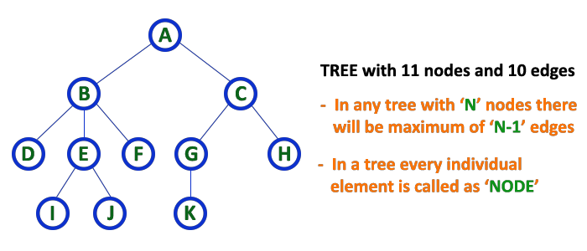

COMPONENTS OF TREE :

In a tree data structure, we use the following terminology...
1.Root:
• In a tree data structure, the first node is called as Root Node.
• Every tree must have a root node. We can say that the root node is the origin of the tree data structure.
• In any tree, there must be only one root node.
• We never have multiple root nodes in a tree
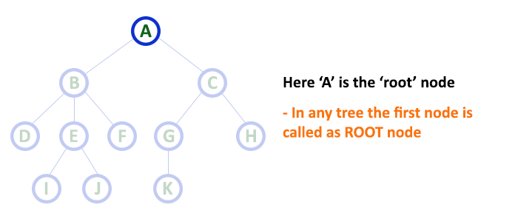

2. Edge:
• In a tree data structure, the connecting link between any two node is called as EDGE.
• In a tree with 'N' number of nodes there will be a maximum of 'N-1' number of edges.
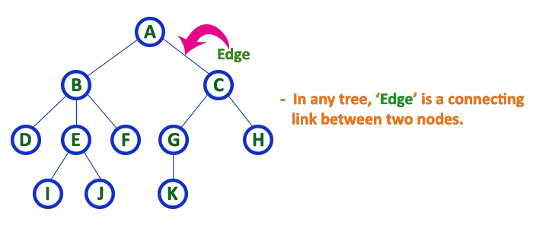

3. Parent:
• In a tree data structure, the node which is a predecessor of any node is called as PARENT NODE.
• In simple words, the node which has a branch from it to any other node is called a parent node.
• Parent node can also be defined as "The node which has child / children"
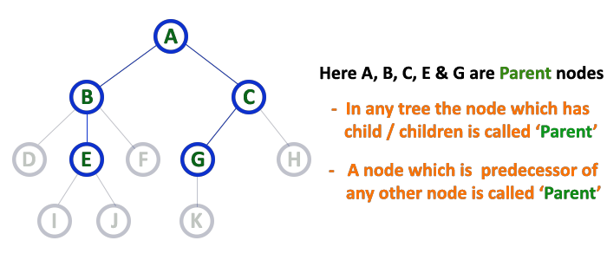

4. Child:
• In a tree data structure, the node which is descendant of any node is called as CHILD Node.
• In simple words, the node which has a link from its parent node is called as child node.
• In a tree, any parent node can have any number of child nodes.
• In a tree, all the nodes except root are child nodes
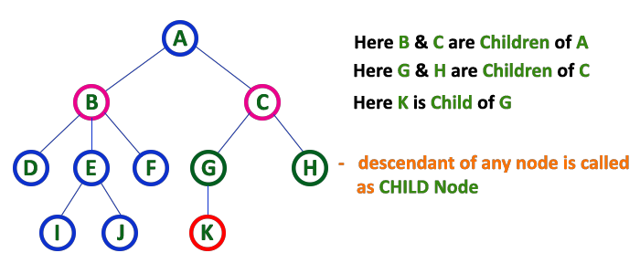
.
5. Siblings:
• In a tree data structure, nodes which belong to same Parent are called as SIBLINGS.
• In simple words, the nodes with the same parent are called Sibling nodes.
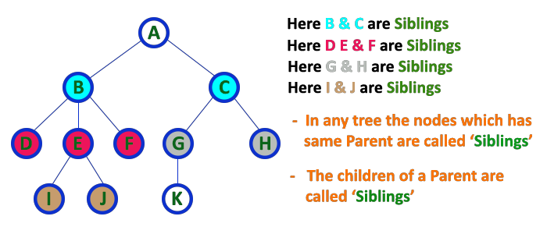

Binary Tree Data structure

In a normal tree, every node can have any number of children. A binary tree is a special type of tree data structure in which every node can have a maximum of 2 children. One is known as a
left child and the other is known as right child.

A tree in which every node can have a maximum of two children is called Binary Tree.

In a binary tree, every node can have either 0 children or 1 child or 2 children but not more than 2 children.

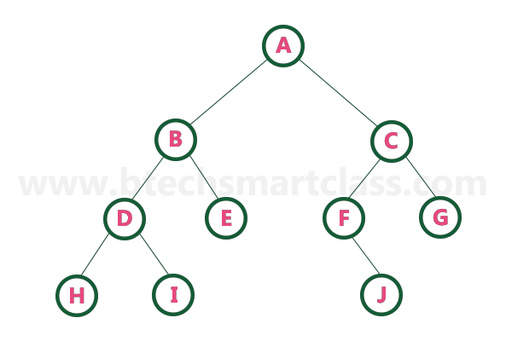

Binary Tree Representations

A binary tree data structure is represented using two methods. Those methods are as follows...
1. Array Representation
2. Linked List Representation
Consider the following binary tree... 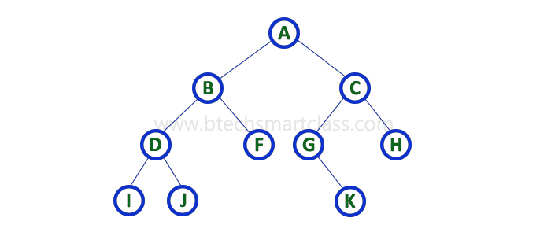

- Array Representation of Binary Tree:

In array representation of a binary tree, we use one-dimensional array (1-D Array) to represent a binary tree.
Consider the above example of a binary tree and it is represented as follows...
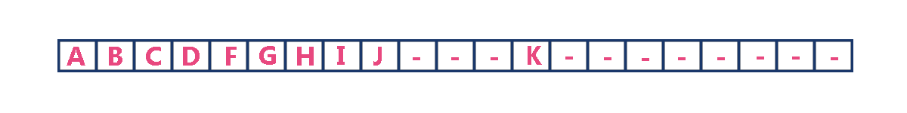
To represent a binary tree of depth 'n' using array representation, we need one dimensional array with a maximum size of 2n + 1

- Linked List Representation of Binary Tree:

➢ We use a double linked list to represent a binary tree. In a double linked list, every node consists of three fields.
➢ First field for storing left child address, second for storing actual data and third for storing right child address.

In this linked list representation, a node has the following structure...



The above example of the binary tree represented using Linked list representation is shown as follows…
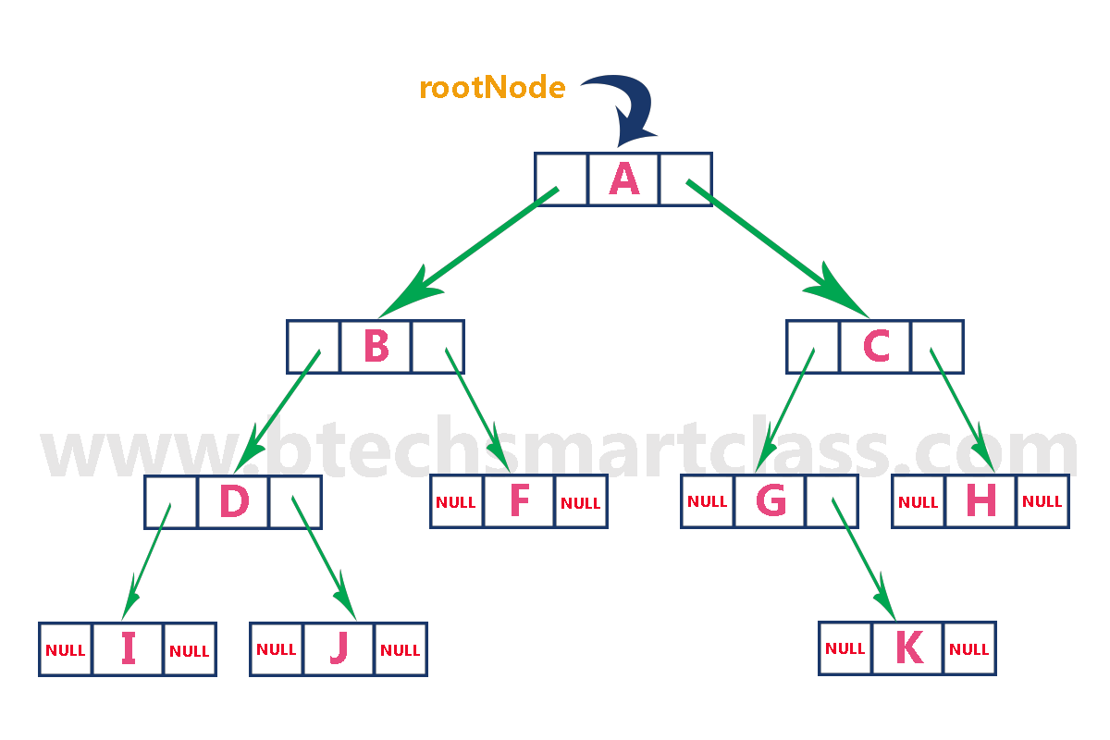
Binary Tree Traversals

When we wanted to display a binary tree, we need to follow some order in which all the nodes of that binary tree must be displayed. In any binary tree, displaying order of nodes depends on the
traversal method.

Displaying (or) visiting order of nodes in a binary tree is called as Binary Tree Traversal.

There are three types of binary tree traversals.

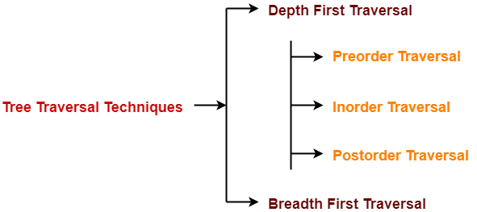

Conclusion:

Tree data structures provide a versatile and efficient way to organize and manage hierarchical data. With their nodes interconnected in a branching structure, trees facilitate quick retrieval, insertion, and deletion operations, making them invaluable in various computing applications such as databases, file systems, and compilers.

